Data Science Unit 4: Data Preprocessing

Unit overview
Part | Syllabus topics | Typical job
Data loading, storage and file formats | Reading and writing text data, binary formats, HTML and web APIs, databases | Turn a CSV file, web page or SQL table into a DataFrame
Data wrangling: clean, transform, merge, reshape | Combining and merging data sets, reshaping and pivoting, data transformation, string manipulation | Join several tables, fix values, change a table's layout
Data aggregation and group operations | GroupBy mechanics, data aggregation, group operations and transformations, pivot tables and cross tabulation | Compute totals and averages per category
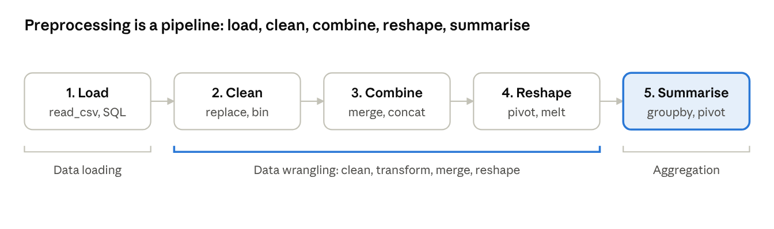
preprocessing pipeline · 5 stages

1. Data Loading, Storage and File Formats
Before analysis, data must be read into a DataFrame; pandas can read and write text files, binary files, web pages, web APIs and databases, usually with one function call.

1.1 Reading and writing data in text format
pd.read_csv is the most used loader. It turns a delimited text file into a DataFrame, guessing column types for you. pd.read_table is the same function with a tab as the default separator.
Option | Purpose | Example
sep | Column separator | sep=";"
header | Row to use as column names (None if there is none) | header=None
names | Supply your own column names | names=["id", "name"]
index_col | Column to use as the row labels | index_col="id"
usecols | Load only some columns | usecols=["id", "marks"]
dtype | Force column types | dtype={"id": str}
na_values | Extra strings to treat as missing | na_values=["NA", "-"]
parse_dates | Convert columns to dates | parse_dates=["joined"]
skiprows / nrows | Skip lines at the top / read only the first n rows | nrows=1000
encoding | Text encoding of the file | encoding="utf-8"
chunksize | Read a big file in pieces | chunksize=100_000
import pandas as pd
df = pd.read_csv("students.csv", index_col="id",
parse_dates=["joined"], na_values=["NA", "-"])
df.to_csv("clean.csv", index=False) # write; index=False leaves out the row labels
total = 0
for chunk in pd.read_csv("big.csv", chunksize=100_000): # each chunk is a DataFrame
total += chunk["amount"].sum() # process a piece at a time
fixed = pd.read_fwf("report.txt") # fixed-width columns
sheet = pd.read_excel("marks.xlsx", sheet_name="Sheet1") # Excel (needs openpyxl)
js = pd.read_json("data.json") # JSON that looks like a table
When the file is JSON with nested structure, load it with Python's json module (json.loads(text)) and then build the DataFrame from the lists and dictionaries you want.

1.2 Binary data formats
Binary formats store data compactly and keep column types exactly, so they load faster than text.
Format | Write and read | Notes
CSV | to_csv, read_csv | Human-readable; every program understands it; types are lost
JSON | to_json, read_json | Readable; the standard format of web APIs
Excel | to_excel, read_excel | For sharing with spreadsheet users
pickle | to_pickle, read_pickle | Any Python object; load only files you trust
HDF5 | to_hdf, read_hdf | Fast for large tables read in parts; needs PyTables
Parquet | to_parquet, read_parquet | Compressed, column-oriented, widely used for big data; needs pyarrow
df.to_pickle("students.pkl")
back = pd.read_pickle("students.pkl")
df.to_parquet("students.parquet") # needs: pip install pyarrow
back = pd.read_parquet("students.parquet")

1.3 Interacting with HTML and web APIs
pd.read_html(url) finds every <table> in a web page and returns a list of DataFrames. For a web API, use the requests library to fetch the response, then turn the JSON into a DataFrame.
tables = pd.read_html("https://example.com/page-with-tables.html") # needs lxml
first = tables[0]
import requests
resp = requests.get("https://api.github.com/repos/pandas-dev/pandas/issues",
params={"per_page": 5})
resp.raise_for_status() # stop with an error for a bad status code
data = resp.json() # a list of dictionaries
issues = pd.DataFrame(data, columns=["number", "title", "state"])
print(issues.head())
Check the status code, respect the site's rate limits and terms of use, and keep any API keys out of your code.

1.4 Interacting with databases
A database table maps naturally to a DataFrame. read_sql_query runs a SQL query and returns the rows; to_sql writes a DataFrame back as a table. SQLite needs only the standard sqlite3 module; for MySQL or PostgreSQL create a connection through SQLAlchemy.
import sqlite3
conn = sqlite3.connect("school.db")
top = pd.read_sql_query("SELECT name, marks FROM students WHERE marks > 60", conn)
top.to_sql("top_students", conn, if_exists="replace", index=False) # write a table
conn.close()
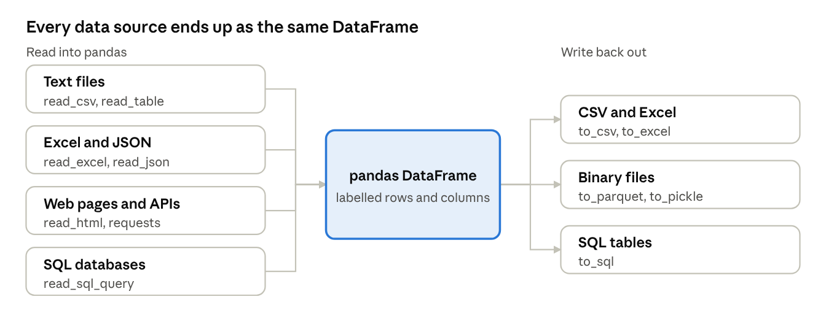
sources, DataFrame and outputs
The same DataFrame methods work no matter where the data came from, which is why loading is the first and simplest step.

2. Combining and Merging Data Sets
Data usually arrives in several pieces; pandas combines them by matching keys (merge), by gluing along an axis (concat) or by filling gaps from another object (combine_first).

2.1 Database-style joins with merge
pd.merge links rows of two DataFrames that share a key, exactly like a SQL join. The how argument decides what happens to rows whose key appears in only one table.
how | Rows kept | SQL equivalent
"inner" (default) | Keys found in both tables | INNER JOIN
"left" | All keys of the left table; missing right values become NaN | LEFT OUTER JOIN
"right" | All keys of the right table | RIGHT OUTER JOIN
"outer" | Keys found in either table | FULL OUTER JOIN
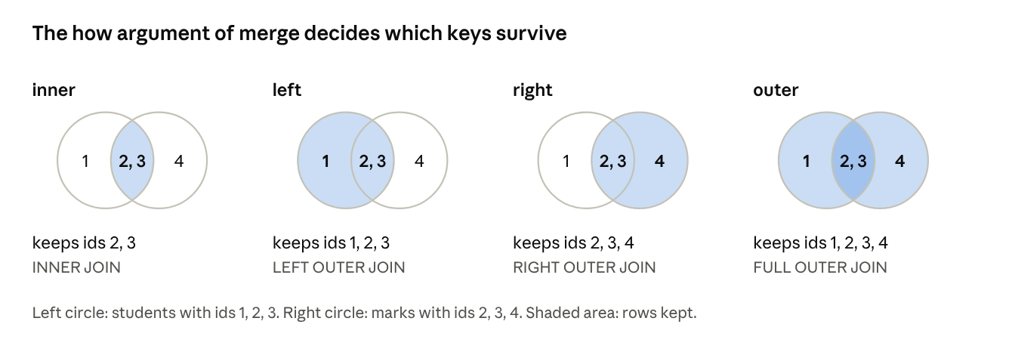
merge join types · 4 Venn pictures
students = pd.DataFrame({"id": [1, 2, 3], "name": ["Asha", "Ravi", "Meena"]})
marks = pd.DataFrame({"id": [2, 3, 4], "marks": [85, 91, 70]})
print(pd.merge(students, marks, on="id")) # inner: ids 2 and 3
print(pd.merge(students, marks, on="id", how="left")) # ids 1, 2, 3 (Asha has NaN marks)
print(pd.merge(students, marks, on="id", how="outer")) # ids 1, 2, 3, 4
# explicit key columns, and suffixes for clashing column names
pd.merge(students, marks, left_on="id", right_on="id", suffixes=("_s", "_m"))
# merge on the row labels instead of a column
pd.merge(students.set_index("id"), marks.set_index("id"), left_index=True, right_index=True)
Useful arguments are on (key column or list of columns), left_on and right_on (different key names), left_index and right_index (use the row labels), suffixes (names for clashing columns) and indicator=True (adds a column showing which table each row came from). DataFrame.join is a shortcut for merging on the row labels. If a key repeats on both sides, the result has every pairing (many-to-many), so check for duplicates first.

2.2 Concatenating along an axis
pd.concat glues objects together instead of matching keys. axis=0 (default) stacks them vertically, adding rows; axis=1 places them side by side, aligning on the row labels.
a = pd.DataFrame({"x": [1, 2]}, index=["r1", "r2"])
b = pd.DataFrame({"x": [3, 4]}, index=["r3", "r4"])
print(pd.concat([a, b])) # 4 rows: r1, r2, r3, r4
print(pd.concat([a, b], ignore_index=True)) # rows renumbered 0 to 3
print(pd.concat([a, b], keys=["first", "second"])) # adds a hierarchical index
print(pd.concat([a, b.rename(index={"r3": "r1", "r4": "r2"})], axis=1)) # side by side
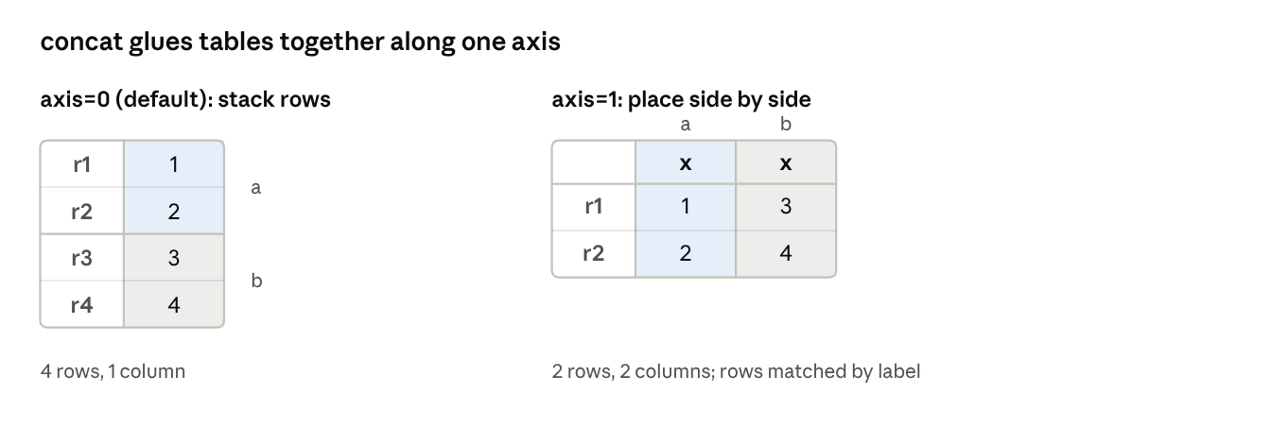
concat along axis 0 and axis 1

2.3 Combining data with overlap
combine_first takes values from the first object and fills its gaps (NaN) from the second, matching on labels. It patches one data set with another.
import numpy as np
primary = pd.Series([1.0, np.nan, 3.0], index=["a", "b", "c"])
backup = pd.Series([10.0, 20.0, 30.0], index=["a", "b", "c"])
print(primary.combine_first(backup)) # a 1.0, b 20.0, c 3.0

3. Reshaping and Pivoting
Reshaping changes the layout of a table without changing its data, most often between a wide layout (one column per category) and a long layout (one row per observation).

3.1 Reshaping with hierarchical indexing
stack() rotates the columns into an inner index level (wide to long) and unstack() rotates an index level into columns (long to wide); Unit 3 explained these on a MultiIndex.

3.2 Pivoting from long to wide
long = pd.DataFrame({
"student": ["Asha", "Asha", "Ravi", "Ravi"],
"subject": ["Maths", "Physics", "Maths", "Physics"],
"marks": [72, 65, 85, 90],
})
wide = long.pivot(index="student", columns="subject", values="marks")
print(wide)
# subject Maths Physics
# student
# Asha 72 65
# Ravi 85 90
pivot needs each index and column pair to occur only once; if pairs repeat, use pivot_table (Section 6), which aggregates them.

3.3 Pivoting from wide to long
pd.melt does the reverse: it keeps the identifier columns and turns the other columns into rows of a variable name and a value.
back = wide.reset_index().melt(id_vars="student",
var_name="subject", value_name="marks")
print(back)
# student subject marks
# 0 Asha Maths 72
# 1 Ravi Maths 85
# 2 Asha Physics 65
# 3 Ravi Physics 90
Layout | Shape | Best for
Wide | One row per student, one column per subject | Reading by eye, spreadsheets, reports
Long | One row per student and subject pair | groupby, plotting libraries and databases
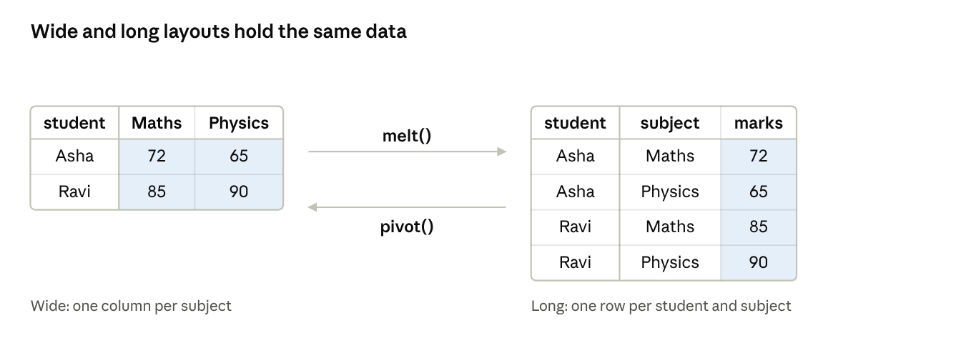
wide and long layouts · melt and pivot

4. Data Transformation
Transformation fixes and reshapes the values themselves: removing duplicates, replacing codes, grouping numbers into bins, handling outliers and encoding categories as numbers.

4.1 Removing duplicates
df = pd.DataFrame({"name": ["Asha", "Ravi", "Asha", "Ravi"],
"dept": ["CSE", "IT", "CSE", "ECE"]})
print(df.duplicated()) # False False True False (marks repeat rows)
print(df.drop_duplicates()) # keeps the first of each repeated row
print(df.drop_duplicates(subset=["name"])) # compare by name only
print(df.drop_duplicates(subset=["name"], keep="last")) # keep the last one instead

4.2 Transforming data using a function or mapping
students = pd.DataFrame({"name": ["asha", "RAVI"], "dept": ["CSE", "IT"]})
students["name"] = students["name"].str.title() # Asha, Ravi
students["school"] = students["dept"].map({"CSE": "Computing", "IT": "Information"})
students = students.rename(columns={"dept": "department"}) # rename columns
students.index = students.index.map(lambda i: "S" + str(i)) # rename row labels

4.3 Replacing values
Real files use codes such as -999 for "no data". replace swaps them for proper missing values.
import numpy as np
s = pd.Series([1, -999, 2, -999, 3])
print(s.replace(-999, np.nan)) # 1.0, NaN, 2.0, NaN, 3.0
print(s.replace([-999, 3], [0, 30])) # several replacements at once
print(s.replace({-999: np.nan, 3: 30})) # same, written as a dictionary

4.4 Discretization and binning
pd.cut sorts continuous values into bins you choose; pd.qcut makes bins that hold roughly equal numbers of values (quantiles). Each bin includes its right edge by default.
ages = [5, 22, 30, 41, 70]
bins = [0, 18, 35, 60, 100] # intervals (0,18], (18,35], (35,60], (60,100]
labels = ["child", "young", "adult", "senior"]
groups = pd.cut(ages, bins=bins, labels=labels)
print(list(groups)) # ['child', 'young', 'young', 'adult', 'senior']
print(pd.Series(groups).value_counts()) # young 2, child 1, adult 1, senior 1
print(pd.qcut(range(100), 4).value_counts()) # four bins of 25 values each
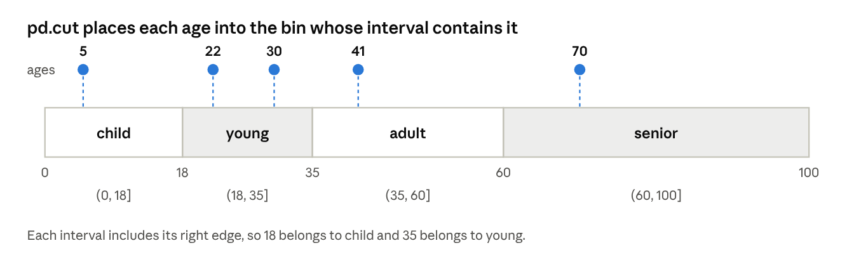
age bins · 4 intervals, 5 values

4.5 Detecting and filtering outliers
An outlier is a value far from the rest. A common rule flags values more than 1.5 times the interquartile range (IQR) beyond the quartiles.
x = pd.Series([10, 12, 11, 13, 12, 95])
q1, q3 = x.quantile(0.25), x.quantile(0.75)
iqr = q3 - q1
low, high = q1 - 1.5 * iqr, q3 + 1.5 * iqr
print(x[(x < low) | (x > high)]) # 95 is flagged as an outlier
print(x[(x >= low) & (x <= high)]) # remove the outlier
print(x.clip(lower=low, upper=high)) # or cap it at the limit

4.6 Dummy variables and scaling
Machine-learning models need numbers, so a category column is converted into one 0/1 indicator column per category with get_dummies. Numeric columns are often rescaled to a common range.
df = pd.DataFrame({"dept": ["CSE", "IT", "CSE"], "marks": [72, 85, 91]})
print(pd.get_dummies(df["dept"], prefix="dept", dtype=int))
# dept_CSE dept_IT
# 0 1 0
# 1 0 1
# 2 1 0
m = df["marks"]
minmax = (m - m.min()) / (m.max() - m.min()) # min-max scaling to the range 0 to 1
zscore = (m - m.mean()) / m.std() # standardising: mean 0, standard deviation 1
To shuffle or sample rows use df.sample(n=2) or df.sample(frac=1); np.random.permutation(len(df)) gives a random ordering of positions.

5. String Manipulation
Text columns need cleaning too: Python's string methods, regular expressions and pandas' vectorized .str methods cover almost every case.

5.1 String object methods
Method | Purpose | Example
split(sep) | Break into a list | "a,b,c".split(",") gives ['a', 'b', 'c']
strip() | Remove whitespace at both ends | " hi ".strip() gives 'hi'
"sep".join(list) | Glue a list into one string | "-".join(["a", "b"]) gives 'a-b'
replace(old, new) | Substitute text | "2026".replace("6", "7") gives '2027'
find(sub) / index(sub) | Position of a match (find gives -1 if none, index raises an error) | "data".find("t") gives 2
count(sub) | Number of occurrences | "banana".count("a") gives 3
startswith / endswith | Test the ends | "file.csv".endswith(".csv") gives True
lower() / upper() / title() | Change case | "asha".title() gives 'Asha'

5.2 Regular expressions
A regular expression (regex) is a pattern that describes a set of strings. Python's re module searches, splits and replaces with such patterns.
Pattern | Matches
\d / \D | A digit / a non-digit
\w / \W | A letter, digit or underscore / anything else
\s | Whitespace
. | Any one character except a newline
*, +, ? | Zero or more, one or more, zero or one of the previous item
{n}, {n,m} | Exactly n, or n to m, of the previous item
[abc], [^abc] | One of a, b, c / any character except a, b, c
^, $ | Start / end of the string
( ) | A group, captured for reuse
import re
text = "Call 98765 43210 or email asha@example.com by 2026-10-09"
print(re.findall(r"\d{5}", text)) # ['98765', '43210']
print(re.search(r"([\w.]+)@([\w.]+)", text).groups()) # ('asha', 'example.com')
print(re.sub(r"\s+", " ", "a b \t c")) # 'a b c'
print(re.split(r"[,;]\s*", "x, y;z")) # ['x', 'y', 'z']
pattern = re.compile(r"(\d{4})-(\d{2})-(\d{2})") # compile once, reuse many times
print(pattern.search(text).groups()) # ('2026', '10', '09')
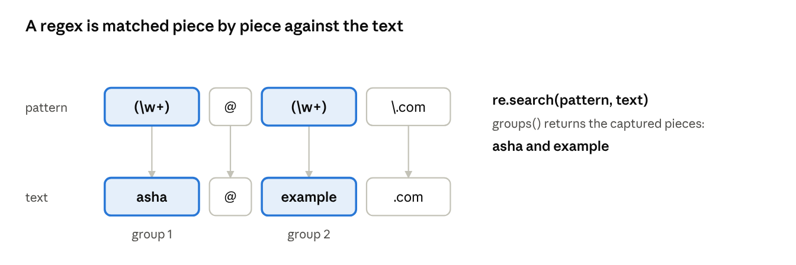
regex pattern matched against text
Use a raw string (r"...") for patterns so that backslashes reach the regex engine unchanged. match tests only the start of a string, while search looks anywhere.

5.3 Vectorized string functions in pandas
The .str accessor applies a string operation to every item of a Series and skips missing values, so you need no loop.
emails = pd.Series(["Asha@Example.com", "ravi@test.org", None])
print(emails.str.lower().tolist()) # ['asha@example.com', 'ravi@test.org', nan]
print(emails.str.contains("example", case=False)) # True, False, NaN
print(emails.str.extract(r"@(\w+)\.")) # domain names: Example, test, NaN
print(emails.str.split("@", expand=True)) # two columns: user and domain
print(emails.str.len()) # 16.0, 13.0, NaN
Method | Purpose
str.lower, str.upper, str.title, str.strip | Clean and change case
str.contains(pat) | True where the pattern is found; use it to filter rows
str.replace(pat, repl) | Substitute text (use regex=True for patterns)
str.extract(pat) | Pull the captured groups of a regex into columns
str.split(sep, expand=True) | Split into separate columns
str.startswith, str.endswith, str.len | Test the ends, count characters

6. Data Aggregation and Group Operations
Summarising data by category is done with the split-apply-combine pattern: split the rows into groups by a key, apply a calculation to each group, and combine the results into one object.
All examples in this section use this DataFrame.
import pandas as pd
df = pd.DataFrame({
"dept": ["CSE", "CSE", "IT", "IT", "IT"],
"gender": ["F", "M", "F", "M", "F"],
"marks": [72, 91, 85, 64, 78],
})

6.1 GroupBy mechanics
df.groupby(key) does not calculate anything yet; it builds a GroupBy object that remembers the groups. Choosing a column and a function then triggers the work.
g = df.groupby("dept")
print(g["marks"].mean()) # CSE 81.5, IT 75.666667
print(g.size()) # CSE 2, IT 3 rows per group
print(df.groupby(["dept", "gender"])["marks"].mean()) # one group per pair of keys
# CSE F 72.0, CSE M 91.0, IT F 81.5, IT M 64.0
for name, group in g: # iterate over the groups
print(name, len(group)) # CSE 2, then IT 3
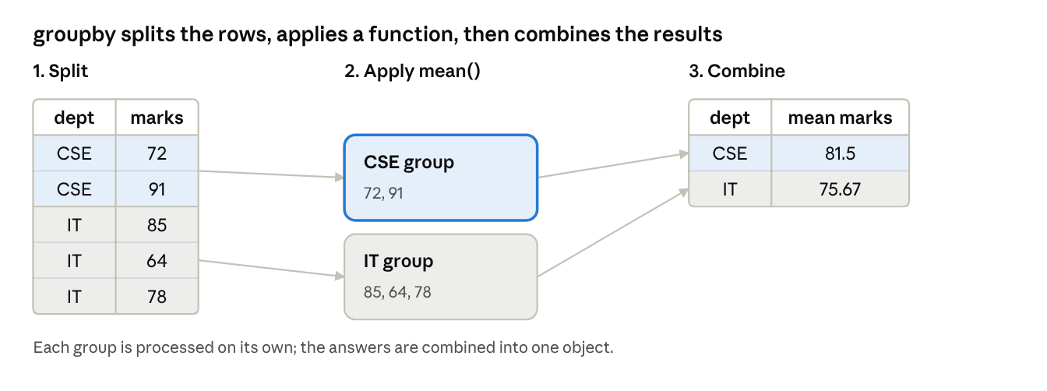
split-apply-combine · 3 stages
You can group by one column, a list of columns, or even a function or dictionary applied to the index. The result of a one-key grouping is indexed by the group names.

6.2 Data aggregation
An aggregation reduces each group to a single value. Common choices are sum, mean, median, min, max, count, std, size, first and last.
print(g["marks"].agg(["min", "max", "mean"])) # several functions at once
print(g.agg(avg=("marks", "mean"), # named aggregation: new column = (column, function)
top=("marks", "max")))
spread = lambda s: s.max() - s.min() # your own function
print(g["marks"].agg(spread)) # CSE 19, IT 21

6.3 Group operations and transformations
- transform returns a result with the same shape as the input, so it can be added back as a column.
- apply runs any function on each group and combines the pieces; it is the most flexible tool.
- filter keeps or drops whole groups by a condition.
- rank, cumsum, shift can also work within each group.
df["dept_mean"] = g["marks"].transform("mean") # each row gets its group average
df["above_avg"] = df["marks"] - df["dept_mean"] # centre each mark on its group
big = df.groupby("dept").filter(lambda d: len(d) >= 3) # keep only departments with 3+ rows
top1 = (df.sort_values("marks", ascending=False)
.groupby("dept").head(1)) # the best row of each department
print(top1[["dept", "marks"]]) # CSE 91, IT 85
Method | Output shape | Typical use
agg | One row per group | Totals, averages, counts per category
transform | Same length as the input | Group-wise scaling, filling gaps with group means
apply | Anything | Custom per-group logic, such as the top n rows
filter | A subset of the original rows | Remove small or unwanted groups

6.4 Pivot tables and cross tabulation
A pivot table is a groupby whose result is arranged as a two-way table: one key down the side, another across the top.
print(pd.pivot_table(df, values="marks", index="dept", columns="gender",
aggfunc="mean", margins=True))
# gender F M All
# dept
# CSE 72.00 91.0 81.500000
# IT 81.50 64.0 75.666667
# All 78.33 77.5 78.000000
↗ building a pivot table
margins=True adds the "All" row and column, fill_value=0 replaces empty cells and aggfunc can be a list such as ["mean", "count"].
A cross tabulation is a special pivot table that counts how often each pair of values occurs.
print(pd.crosstab(df["dept"], df["gender"]))
# gender F M
# dept
# CSE 1 1
# IT 2 1
print(pd.crosstab(df["dept"], df["gender"], normalize="index")) # each row sums to 1
Tool | Best for
groupby + agg | A flexible summary with several keys and several functions
pivot_table | A summary shown as a two-way table
crosstab | Counting combinations of two categorical columns

Quick revision
Remember one core idea for each topic.
- Text formats: read_csv (with sep, header, index_col, na_values, parse_dates, chunksize) and to_csv(index=False).
- Binary formats: pickle, HDF5 and Parquet keep types and load faster; load pickles only from trusted sources.
- HTML and web APIs: read_html returns a list of DataFrames; requests.get(...).json() then pd.DataFrame(...) for an API.
- Databases: read_sql_query to load a query result, to_sql to save a table.
- merge: a SQL-style join on keys; how is inner, left, right or outer.
- concat: stacks rows (axis=0) or places objects side by side (axis=1); combine_first fills gaps from another object.
- Pivoting: pivot goes long to wide, melt goes wide to long, stack and unstack move index levels.
- Duplicates and replacement: drop_duplicates, replace(-999, np.nan), map, rename.
- Binning: cut uses bin edges you choose; qcut uses quantiles.
- Outliers and dummies: flag values beyond 1.5 times the IQR; get_dummies creates one indicator column per category.
- Strings: string methods, re patterns, and the vectorized .str accessor in pandas.
- GroupBy: split, apply, combine; agg reduces, transform keeps the shape, apply is flexible, filter drops groups.
- Pivot tables and crosstab: pivot_table summarises with an aggregation function; crosstab counts combinations.

Likely exam questions
Short answer (2 to 3 marks)
- List any four options of read_csv and state their use.
- Differentiate between merge and concat.
- What is the difference between the inner and outer join?
- What is the difference between pivot and melt?
- Differentiate between cut and qcut.
- What is a dummy variable? How is it created?
- What is the split-apply-combine strategy?
- Differentiate between pivot_table and crosstab.
Long answer (5 to 10 marks)
- Explain how data is read from and written to text files, binary files, web pages and databases using pandas.
- Explain the different ways of combining and merging data sets, with examples.
- Explain reshaping and pivoting, with an example of converting between long and wide formats.
- Explain the data transformation methods: removing duplicates, replacing values, binning and outlier detection.
- Explain string manipulation with string methods, regular expressions and the pandas .str functions.
- Explain GroupBy mechanics with aggregation and transformation examples.
- Explain pivot tables and cross tabulation with examples.

References

Text books
- Mark Lutz, Learning Python, O'Reilly.
- Mark Lutz, Programming Python, O'Reilly.
- Wes McKinney, Python for Data Analysis, O'Reilly (data loading and file formats, data wrangling, data aggregation and group operations).

Reference books
- Martin C. Brown, Python: The Complete Reference, McGraw Hill Education.
- Paul Barry, Head First Python, O'Reilly.

